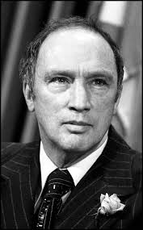
Pierre Trudeau

Use the resources below to answer the following questions:

- Provide some background information about the person
- What did they want to change?
- What change ultimately happened and was it the intended change?
- how does that change impact us today? Is it a positive or a negative change (or both)?

- Read the article: http://www.biography.com/people/pierre-trudeau-9510956

- Read the article: http://www.cbc.ca/news2/pointofview/2010/09/pierre-trudeau-did-he-have-a-positive-or-negative-impact-on-canada.html

- Watch the video: https://www.youtube.com/watch?v=t2jsVpI4Vh8

- Watch the video: https://www.youtube.com/watch?v=ngYEcae6ndE

