Stephen Harper
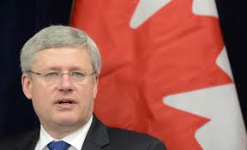

Use the resources below to answer the following
questions:

- Provide some background information about the person
- What did they want to change?
- What change ultimately happened and was it the intended change?
- how does that change impact us today? Is it a positive or a negative change (or both)?

- Watch the video: https://www.youtube.com/watch?v=ER2eZ6CwPP4
- Read the biography: http://pm.gc.ca/eng/prime-minister-stephen-harper
- Read the article http://pm.gc.ca/eng/news/2014/12/31/prime-minister-stephen-harper-highlights-governments-2014-achievements
- Look at the cartoon:

